
Maryland State Police
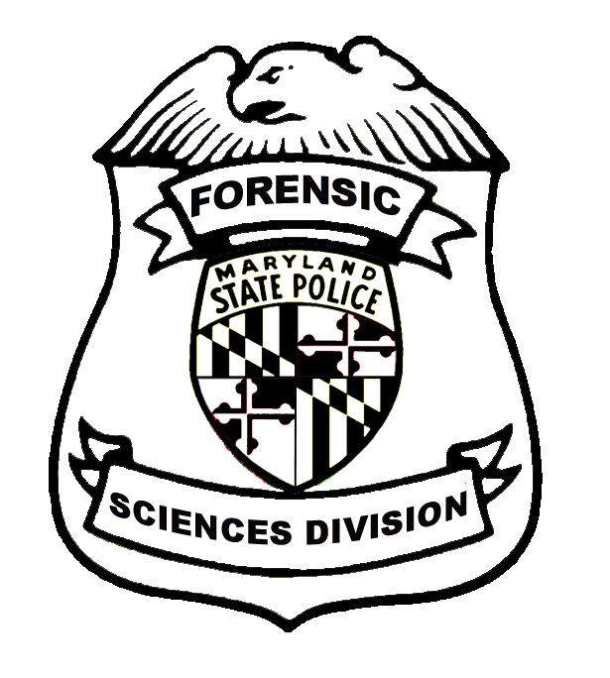
Forensic Sciences Division

Witness Evaluation Form

The purpose of this questionnaire is to collect information to help our laboratory evaluate its level of service in the area of providing expert testimony. We encourage constructive criticism. After completing the form, return it to the Forensic Sciences Division [fax or fold in half, staple and submit by mail]. Please call Director Long if you would like to discuss your remarks. Thank you for your assistance.

Director Teresa M. Long
Maryland State Police Forensic Sciences Division
221 Milford Mill Road
Pikesville, Maryland 21208
Tel: (443) 357-1300/Fax: (443) 357-1320

DATE: ___________________________ | COURT: ________________________ | WITNESS NAME: ________________________________
TYPE OF CASE: __________________ | DEFENDANT’S NAME: _______________________________________________________________

 |  |  |  |  | YES | NO
1. Was witness on time?
2. Did witness come prepared with relevant documents?
3. Was witness presentable in appearance?
4. Was witness cooperative with judge and attorneys?
5. Did witness speak clearly and distinctly?
6. Did witness answer questions directly?
7. Did witness show good knowledge of technical subject?
8. Was the testimony presented in a manner understandable to a lay jury?
9. Did witness exhibit good courtroom demeanor?
OVERALL RATING
Outstanding | Very Good | Good | Average | Poor | Unacceptable
COMMENTS

Your Name: ________________________ (optional) Telephone Number: ______________________
Prosecutor [ ] Defense Attorney [ ] Judge [ ] Peer Observer [ ] Supervisor Observer [ ]

Place
Postage
Here

Mrs. Teresa M. Long
Director
Maryland State Police
Forensic Sciences Division
221 Milford Mill Road
Pikesville, Maryland 21208

